Module | WSQ- Business Analytics (SF)
Name | Koh Chun Yao
Date | 20 Feb 2026

Assignment-4a Submission

Task 1 – DESIGN PAGE 1

Provide screenshot of Report Page 1

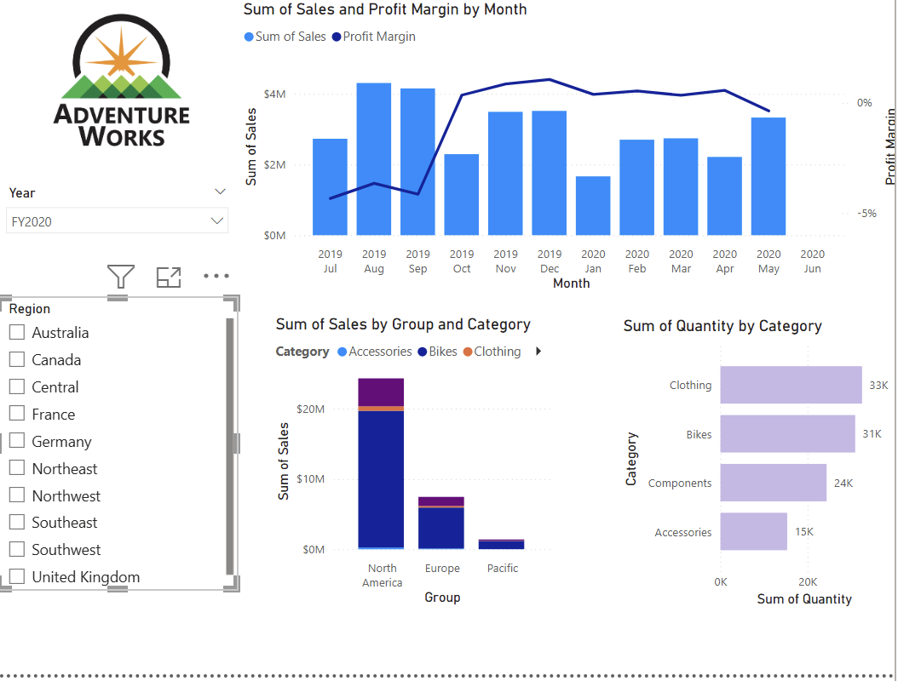

Task 2 – DESIGN PAGE 2

Provide screenshot of Report Page 2

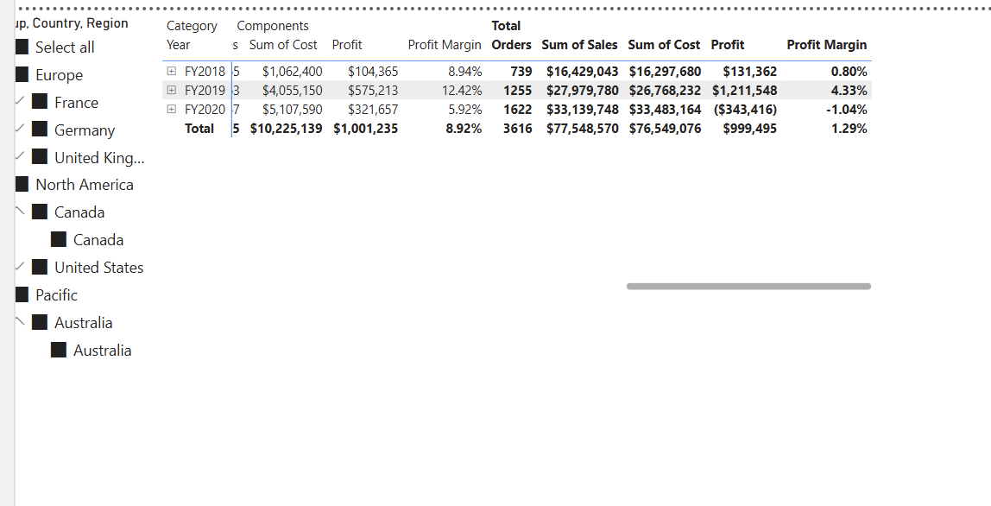

Task 3 - DESIGN PAGE 3

Provide screenshot of Report Page 3

